**Specialist Mathematics Units 3 & 4**

**Investigation 2 2018**

**Numerical Integration**

**Take Home Section – due Tuesday 17 July**

**A validation test will be given on the day the assignment is due. Use of CAS calculator is assumed and your Take Home paper will be allowed. The validation score will account for 100% of the marks allocated.**

**Part 1: Take Home Component**

**INTRODUCTION**

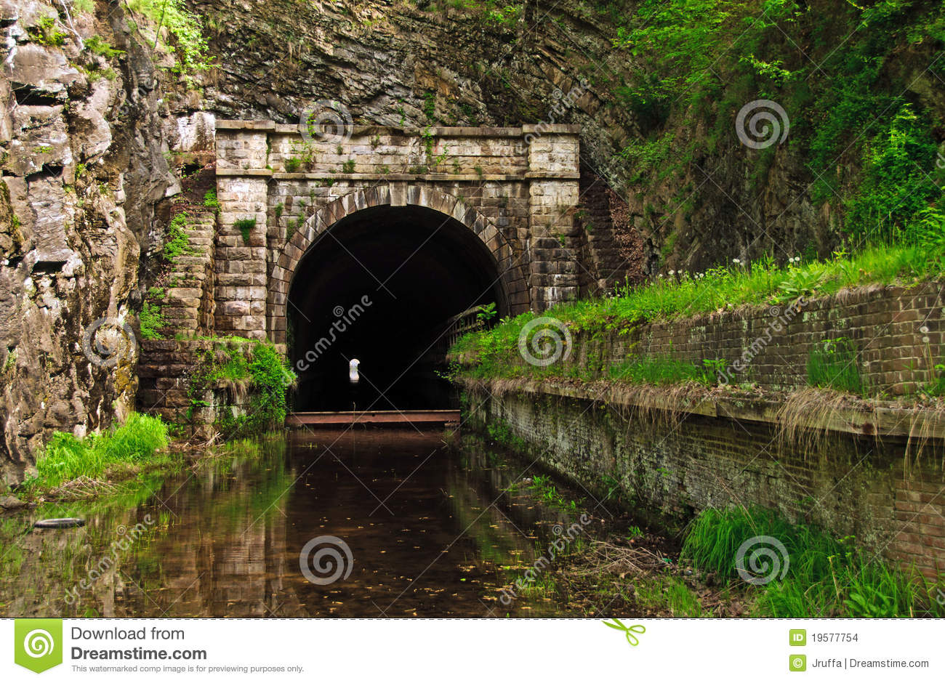Before Leibniz and Newton uncovered the process of differentiation and therefore anti-differentiation in the 17th. century mathematicians were forced to calculate areas like the one of the tunnel below in a more demanding manner.

The area bounded by the curve $y=2x-\frac{1}{8}x^{2}$ and the x **-** axis from x= 2 to x= 14 can be evaluated by the definite integral:

$$\int_{2}^{14}{\left(2x-\frac{x^{2}}{8}\right)dx}$$

This calculation is only possible if we can find a function which has $2x-\frac{x^{2}}{8}$ as its derivative.

$\left(1-tanx\right)e^{sinx}$ and $e^{-x^{2}}$ are examples of functions that have no accessible antiderivative.

Where it is not possible to find such a function, a mathematician resorts to techniques of numerical integration to obtain approximations for an integral and is able to control the degree of accuracy.

The Greek mathematician Archimedes (287-212 BC) was able to calculate the area of segments of a parabola without any knowledge of modem calculus. His technique was called "method of exhaustion"!

A useful application of integration was finding the area bounded by a function and the horizontal axis between certain limits.

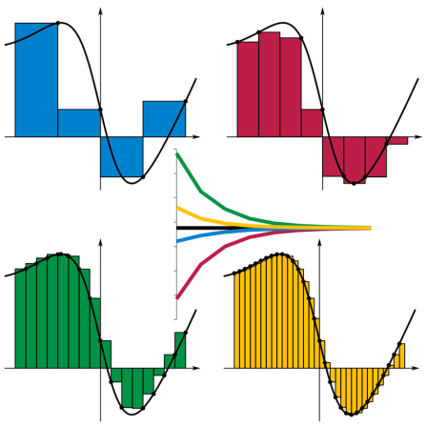For $y=f(x)$ shown in the diagram:  the sum of the areas of the rectangles.

If we increase the number of rectangles our estimate improves accordingly.

This is the basis of many methods of numerical integration that focussed on approximating the area under the curve.

Your task is to investigate numerical methods, in particular the Trapezium Rule & Simpson’s Rule

**A QUESTION OF ACCURACY**

This investigation involves numerical methods used to evaluate integrals. Throughout you are required to give **final results correct to3 decimal places**. To achieve this degree of accuracy, you will need to carry extra decimal places in earlier calculations.

Many of the calculations to come will be made much easier and more accurate if you get to know the capabilities of your graphic calculator with respect to the

operation. When justifying your solutions you may use the sigma symbol with the correct formula, where appropriate, rather showing the full list of values.

Take Home Questions

1. Apply the Trapezoidal/Trapezium rule to approximate $\int_{2}^{14}{(2x-\frac{x^{2}}{8}})dx$ using 12 strips.

2. Use Simpson's Rule to approximate the same integral with the same number of strips.

3. Compare the percentage error for both the above.

|  |  |
| --- | --- |
| $$x$$ | $$f(x)$$ |
| 2 | 3.5 |
| 3 | 4.875 |
| 4 | 6 |
| 5 | 6.875 |
| 6 | 7.5 |
| 7 | 7.875 |
| 8 | 8 |
| 9 | 7.875 |
| 10 | 7.5 |
| 11 | 6.875 |
| 12 | 6 |
| 13 | 4.875 |
| 14 | 3.5 |

Take Home Answers

1. , using Trapezium Rule with 12 strips

Area = ½[ $f\left(2\right)+f\left(14\right)$ +2(

✓ ✓ ✓

= ½[ $3.5+3.5$ +2($4.875+6+6.875+7.5+7.875+8+7.875+7.5+ 6.875+6+4.875]$

= 77.75 units2 ✓

or ✓ ✓ ✓

Area = ½ ( +)

= 77.75 units2 ✓

2. , using Simpson’s Rule with 12 strips

Area = $\frac{1}{3}$ [$f\left(2\right)+f\left(14\right)$ +4(

* ✓ ✓

= [+4($4.875+6.875+7.875+7.875+6.875+ 4.8752)+2(6+7.5+ 8+7.5+6)]$

or $\frac{1}{3}$ [ $3.5+3.5$ + 4 $×$ 39.25

* ✓ ✓ ✓

or $\frac{1}{3}$ [ $3.5+3.5$ + 4

✓

= 78 units2

3. by integration using an antiderivative is 78 units2 ✓

Percentage Error (Trapezium Rule) = $\frac{78-77.75}{78}$ x 100 = 0.321% (3dp) ✓✓

Percentage Error (Simpson’s Rule) = 0.000 % ✓